|  |  |
| --- | --- |
| **SARDAR PATEL COLLEGE OF ENGINEERING, BAKROL, ANAND** | |
| **Subject Name : Operating System & Virtualization** | **Semester: 4th** |
| **Subject Code: 3141601** | **Branch: I.T.** |

**Assignment - 2**

|  |  |
| --- | --- |
| **Given Date: 24/01/2020** | **\*Last Date: 03/02/2020** |

1. Explain PCB in detail.
2. Explain process state diagram in detail.
3. Difference between process and thread & Explain thread in detail.
4. Following table gives arrival time and expected run time of five processes.

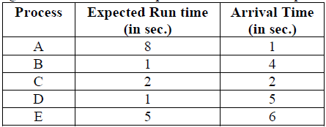

Ignore process switching overhead. Find average turnaround time for following scheduling algorithm.

1. Round robin (quantum = 1 sec)

2. Shortest Job First (Preemptive & Non-Preemptive).

3. First Come First Serve

5. What is scheduler? Explain queuing diagram representation of process scheduler with figure.

**\*Note : Consider the last date as final deadline to submit the assignment. After the last date assignment will not be accepted in any case.**